# Calculating binomial probabilities

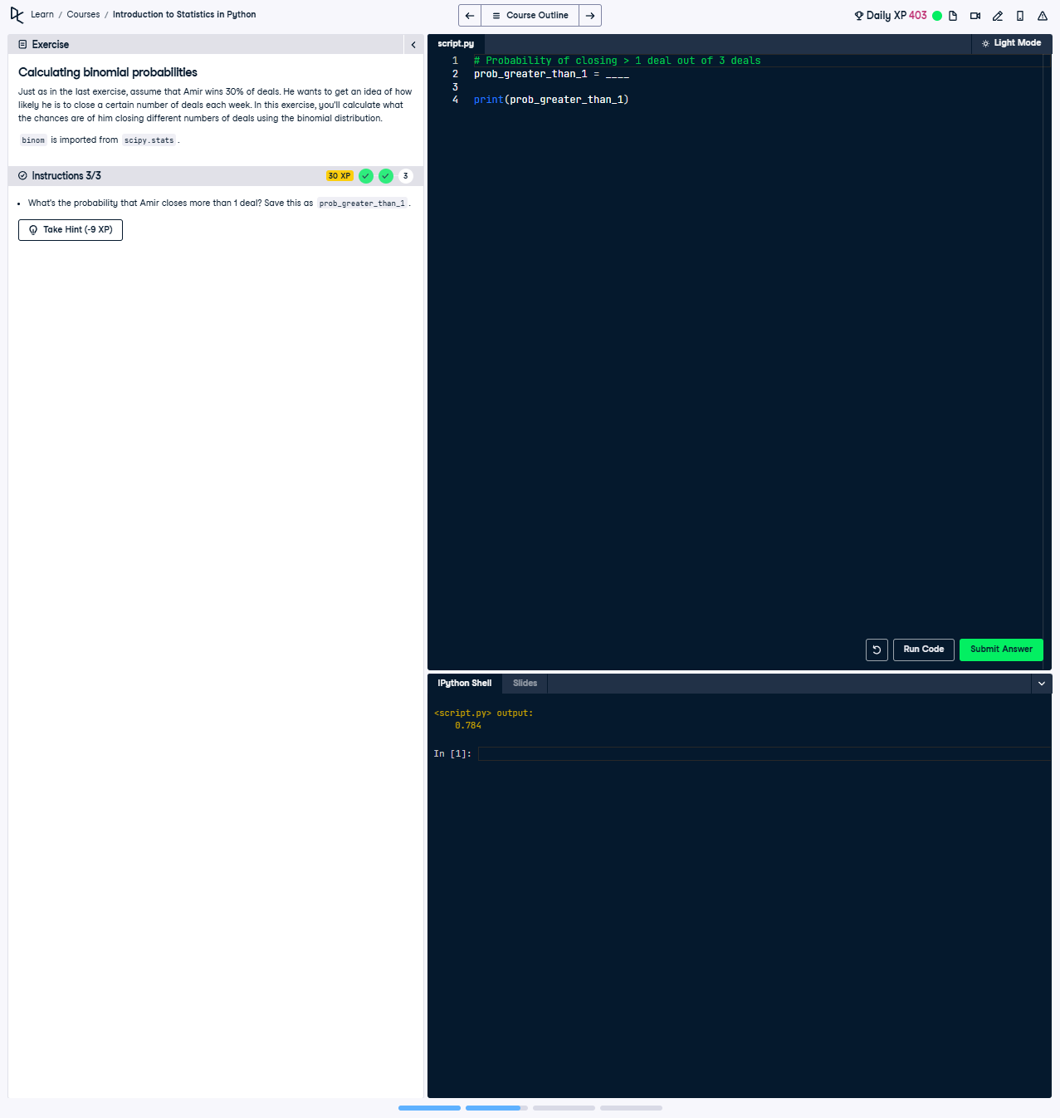

## Question:

What's the probability that Amir closes more than 1 deal? Save this as prob_greater_than_1.

## Explanation of the Question:

This question asks us to calculate the probability of achieving more than 1 successful outcome out of 3 trials, where the success probability for each trial is 30%. This involves calculating the cumulative probability of 0 and 1 successes and subtracting that from 1.

## Answer:

from scipy.stats import binom  
  
# Calculate the probability of getting more than 1 success  
prob_greater_than_1 = 1 - binom.cdf(1, 3, 0.3)  
  
print(prob_greater_than_1)

## Explanation of the Answer:

The solution calculates the probability of achieving more than 1 successful outcome using the cumulative distribution function (CDF) for the binomial distribution. The CDF gives the probability of getting at most a certain number of successes. Subtracting the CDF for 1 success from 1 gives the probability of getting more than 1 success.